**CS 207: Applied Database Practicum**

**In-Class Activity 4: Introduction to GROUP BY, ORDER BY, UNION and Mysql Joins, 16th September, 2019**

In this activity, you will be working in Mysql.

Q1. In this question load the dump file “world.sql” given in moodle and perform the following actions:

i) List the number of countries and total SurfaceArea of each continent

ii) List the continent, number of countries in each continent sorted in descending order

ii) Show the Continent and calculate Population density of each continent in descending order

Population density = $\frac{Total Population}{Total Surface Area}$

Q2. In this question load the database from the dump file (join.sql) given in moodle

The Database has the following tables:

* Customers: stores customer’s data.
* Products: stores a list of scale model cars.
* Orders: stores sales orders placed by customers.

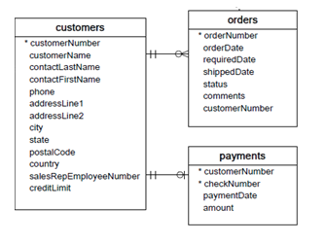

1. Display all customer names (**customers table**) and their orderNumbers (**orders table**).
2. Show the number of orders (**orders table**) placed by each customer (**customers table**).
3. Display all customer names (**customers table**) that have not placed any orders (**orders table**)
4. Display all the customer details (**customers table**) and payment details (**Payments table**) for the **customerNumber 119.** (There should be no redundant columns)
5. Find the total amount (**payments table**) paid by each customer (**customers table**).
6. Display the total amount paid (**payments table**) for each order (**orders table**)

BONUS: ONLY if you have done the above steps, then you can try this bonus for an extra point.

1. Show the country, HeadOfState from continents ASIA and Europe using UNION operator. The result table should be in alphabetical (A-Z) order of HeadofState.